Control flow / Flow control :

Flow control : Control flow describes the order in which the statements will be executed at run time.

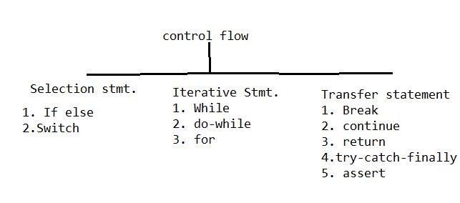Selection stmt.: Among several options only one option will be selected and executed is a select stmt.

Itarative Stmt : a group of statements will be executed iteratively.

Transfer Stmt: which transfers the control.

**If-else** : The Java if statement is used to test the condition. It checks boolean condition: true or false.

SYNTAX : if(P) ******* P should be Boolean **************

{

// Executes if P is true

}

else

{

// Executes if P is False

}

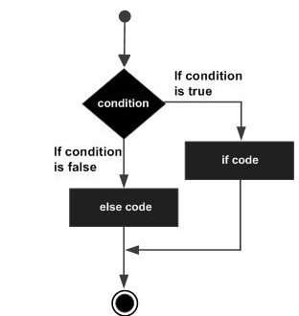Show example from eclipse.

**Switch** : The Java switch statement executes one statement from multiple conditions.

switch(expression) {

case value :

// Statements; break; // optional

case value :

// Statements; break; // optional

default : // Optional

// Statements;

}

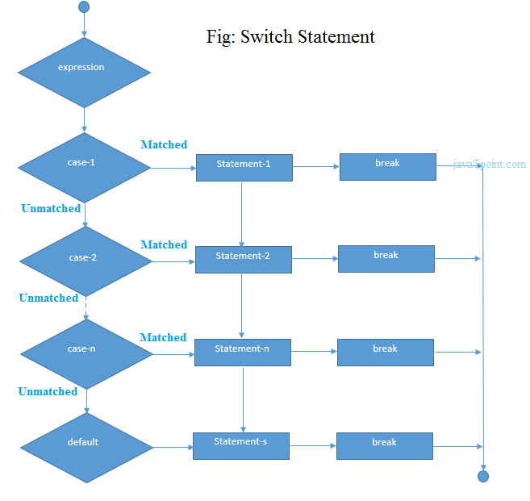Exapmle is in eclipse > switch

**While loop :**

A **while** loop statement in Java repeatedly executes a target statement until a given condition is true.

while(Boolean_expression) // Strictly a Boolean expression

{

// Statements

}

Example in eclipse

**Do while loop :**

A **do...while** loop is similar to a while loop, except that a do...while loop is guaranteed to execute at least one time.

do {

// Statements

} while(Boolean_expression); // Strictly a Boolean expression //requires ;

Example in eclipse

**For loop:**

The Java for loop is used to iterate a part of the program several times. If the number of iteration is fixed, it is recommended to use for loop.

1. **for**(initialization; condition; increse/decrese)
2. {
3. //code to be executed
4. }

**Break statement:**

**Using break statement**: When a break statement is encountered inside a loop, the loop is terminated, and program control resumes at the next statement following the loop.

OR

The Java break is used to break loop or switch statement. It breaks the current flow of the program at specified condition.

Example in Eclipse

**Continue statement:**

**Using continue statement**: When a continue statement is encountered inside the body of a loop, remaining statements (**ONLY** statements written after continue are skipped) are skipped and loop proceeds with the next iteration.

Example in eclipse